**EX 10: Conditional Content**

You're working on a part of a web app that's responsible for **showing a warning** when a user is about to perform a dangerous action.

Therefore, your task is to **conditionally** show a warning box once a user has **clicked** a specific button. Inside that warning dialog, another button allows users to **dismiss the warning** (i.e., remove the warning box from the screen).

The finished app should display this UI, if the <button> has not been clicked yet:



And this UI, once the button was clicked:

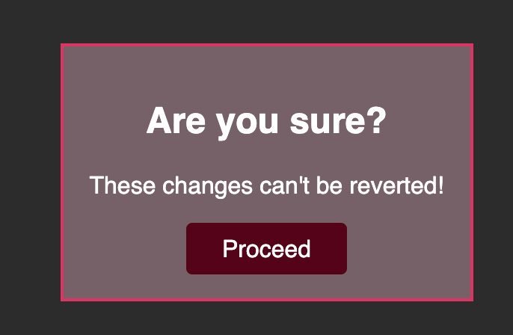

Once the "Proceed" button was clicked, the warning box should be removed again:



For this task, you must react to clicks on both <button> elements that are part of the starting code. The second button, outside of the <div> with the id="alert", should show the <div id="alert"> (and all its content). The button inside that <div> should then hide it again (i.e., remove it from the DOM).

It's up to you whether you want to use a ternary expression or store the conditionally shown JSX code in a variable.

Important: In this Udemy code editor you may get an error if you use useState() - use React.useState() instead!